Brought Lt Governor Gilchrist to Ogemaw to have a conversation about Michigan and our community, shared a tour of businesses in our area

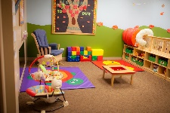
Recognizing that child care is a barrier for working parents, promoted the new child care Tri-share program in our County as well as wrote for, or partnered with, 3 child care grants that will directly benefit Ogemaw County, (to-date one was received and two are pending)

Held annual Economic Outlook Breakfast for County business and community leaders, with Keynote Speaker Sarah Lucas, Director of Rural Development

Participated in the Business Expo to promote Ogemaw County businesses, Michigan Works! and the Ogemaw County EDC
Brought together officials from townships/cities/county for updates on ARPA funding and reporting; 2 sessions held in partnership with MSU Extension
Continued development of the Revolving Loan Fund in Ogemaw County to offer low interest loans for small businesses
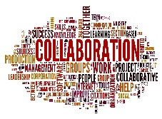
Created an Ogemaw Community Collaborative Working Group to focus on child care, broadband, housing, and other pain-points for the County.
Active in multiple site-selection operations for the Ogemaw area
EDC Director continued special training to support her position

